21 When implementing linear regression of some dependent variable 𝑦 on the set of independent variables 𝐱 = (𝑥₁, …, 𝑥ᵣ), where 𝑟 is the number of predictors, which of the following statements will be true?
A) 𝛽₀, 𝛽₁, …, 𝛽ᵣ are the regression coefficients.
b) Linear regression is about determining the best predicted weights by using the method of ordinary least squares.
c) E is the random interval
d) Both and b
ans. d) Both and b
linear regression is a statical method that is used to model the relationship between a
dependent variable y and one or more independent variables x
the dependent variable y is also called response or outcome variable, and the independent variables x are also called the predicator or explanatory variables.
thr linear regression model assume that the conditional mean of y given x is an affine function of x
which means it can be written as
$$y=β_{0}+β_{1}x_{1}+β_{2}x_{2}+...+β_{r}x_{r}+ϵ$$
𝛽₀, 𝛽₁, …, 𝛽ᵣ are indeed the regression coefficients. 𝛽₀ represents the intercept, and 𝛽₁, …, 𝛽ᵣ are the coefficients corresponding to the independent variables 𝑥₁, …, 𝑥ᵣ.
22) What indicates that you have a perfect fit in linear regression?
a) The value 𝑅² < 1, which corresponds to SSR = 0
b) The value 𝑅² = 0, which corresponds to SSR = 1
c) The value 𝑅² > 0, which corresponds to SSR = 1
d) The value 𝑅² = 1, which corresponds to SSR = 0
ans. d) The value 𝑅² = 1, which corresponds to SSR = 0
in linear regression, 𝑅² measures the proportion of the variance in the dependent variable y that
is explained by the independent variables 𝑥₁, …, 𝑥ᵣ. It ranges from 0 to 1, where the value of 1, where a value of 1 Indicate a perfect fit .
sum of sequence residuals represent the sum of squared difference between the observed value of the dependent variable and predict values from the regression line
23) In simple linear regression, the value of what shows the point where the estimated regression line crosses the 𝑦 axis?
a) Y
b) B0
c) B1
d) F
ans. b) B0
in a simple linear regression, the estimated regression line is represented by the equation 𝑦 = 𝛽₀ + 𝛽₁𝑥
here, 𝛽₀ is the intercept of the regression line, which indicate the point where the line crosses the y-axis. it’s the value of dependent variable y when the indicate variable x is equal to 0.

24) Check out these four linear regression plots:
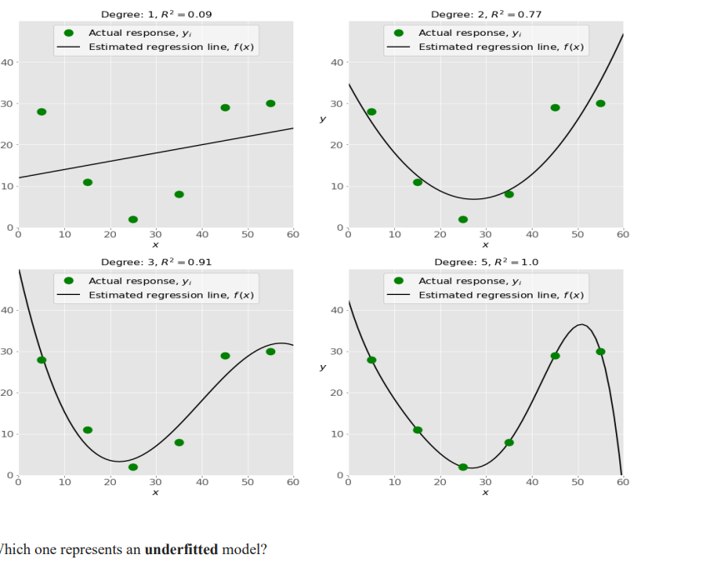
a) The bottom-left plot
b) The top-right plot
c) The bottom-right plot
d) The top-left plot
ans. d) The top-left plot
the top-left plot shows a linear regression line that has low 𝑅². It important that a straight line can’t fit the data well.
25) There are five basic steps when you’re implementing linear regression: • a. Check the results of model fitting to know whether the model is satisfactory. • b. Provide data to work with, and eventually do appropriate transformations. • c. Apply the model for predictions. • d. Import the packages and classes that you need. • e. Create a regression model and fit it with existing data. However, those steps are currently listed in the wrong order. What’s the correct order?
a) e, c, a, b, d
b) e, d, b, a, c
c) d, e, c, b, a
d) d, b, e, a, c
ans. d) d, b, e, a, c
26) Which of the following are optional parameters to Linear Regression in scikit-learn?
a) Fit
b) fit_intercept
c) normalize
d) copy_X
e) n_jobs
f) reshape
ans. Fit_intercept , normalize, copy_X and _jobs
27) While working with scikit-learn, in which type of regression do you need to transform the array of inputs to include nonlinear terms such as 𝑥²?
A) Multiple linear regression
b) Simple linear regression
c) Polynomial regression
ans. c) Polynomial regression
polynomial regression is a type of regression in which the relation between tj=he independent variable X
and dependent variable Y is modeled as an nth degree polynomial.
28) You should choose statsmodels over scikit-learn when:
A) You want graphical representations of your data.
b) You’re working with nonlinear terms.
c) You need more detailed results.
d) You need to include optional parameters
ans. d) You need to include optional parameters
29) _________ is a fundamental package for scientific computing with Python. It offers comprehensive mathematical functions, random number generators, linear algebra routines, Fourier transforms, and more. It provides a high-level syntax that makes it accessible and productive.
a) Pandas
b) NumPy
c) Stats model
d) SciPy
ans. b) NumPy
30 ) _________ is a Python data visualization library based on Matplotlib. It provides a high-level interface for drawing attractive and informative statistical graphics that allow you to explore and understand your data. It integrates closely with pandas data structures.
a) Bokeh
b) Seaborn
c) Matplotlib
d) Dash
ans. b) Seaborn

